Jackson Warren

Jeremy Bergen

CSCI 370

10/22/21

Week 7 Lab

Section 1:

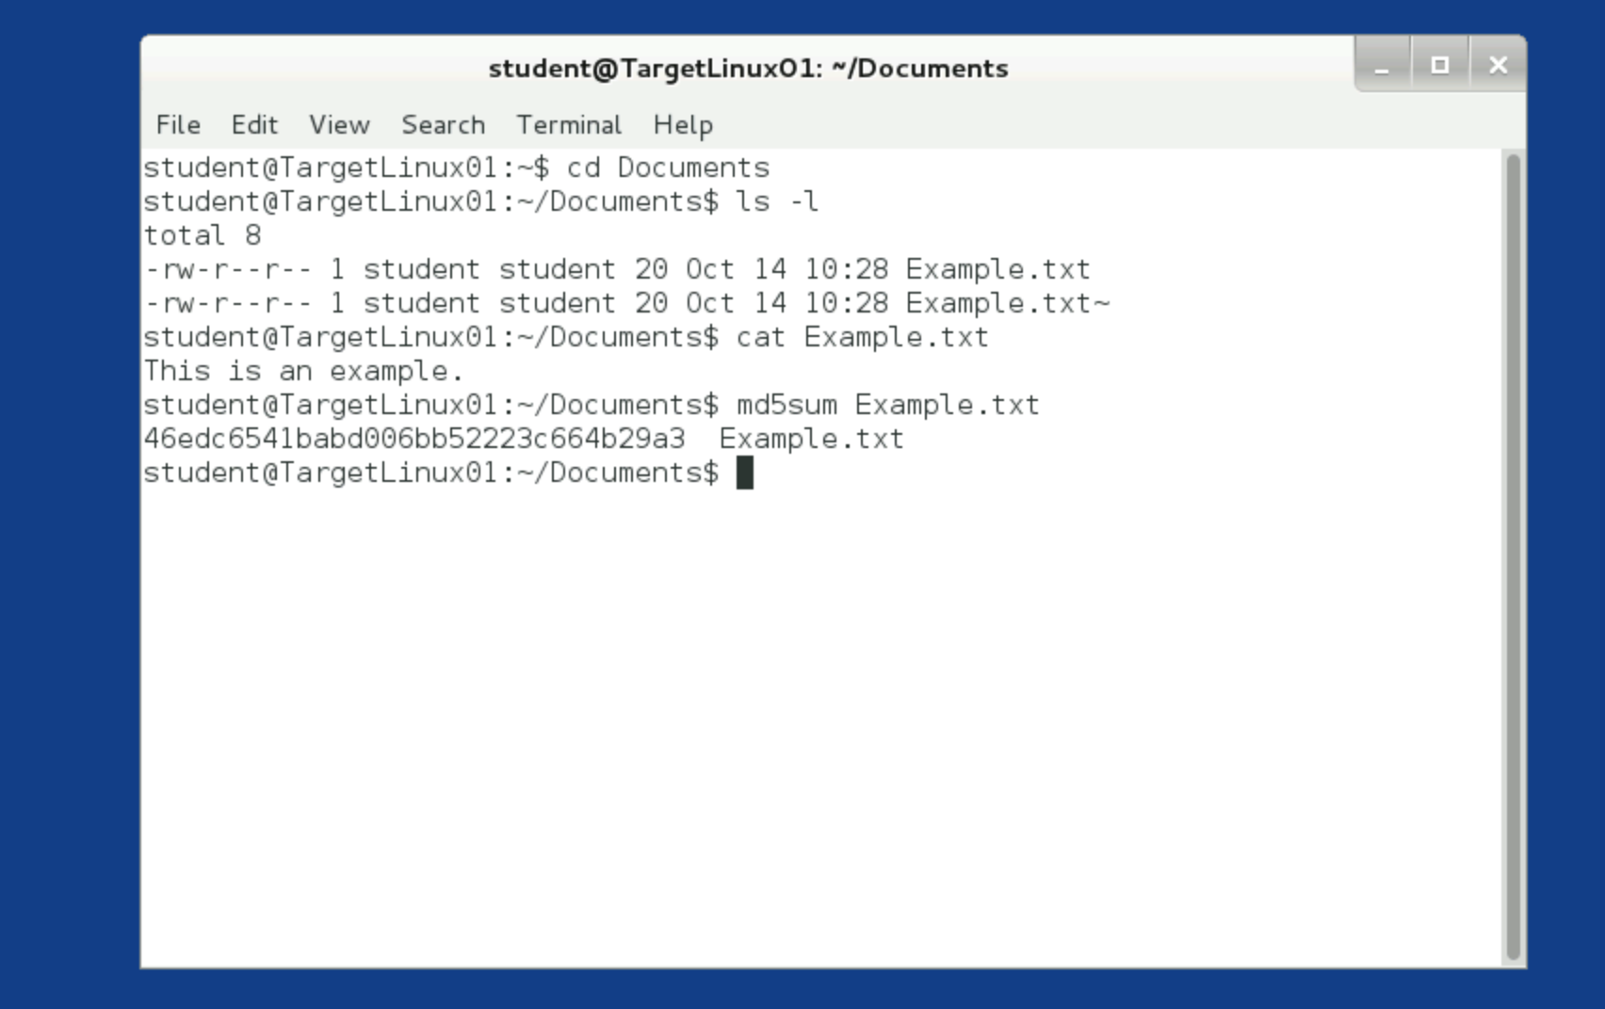

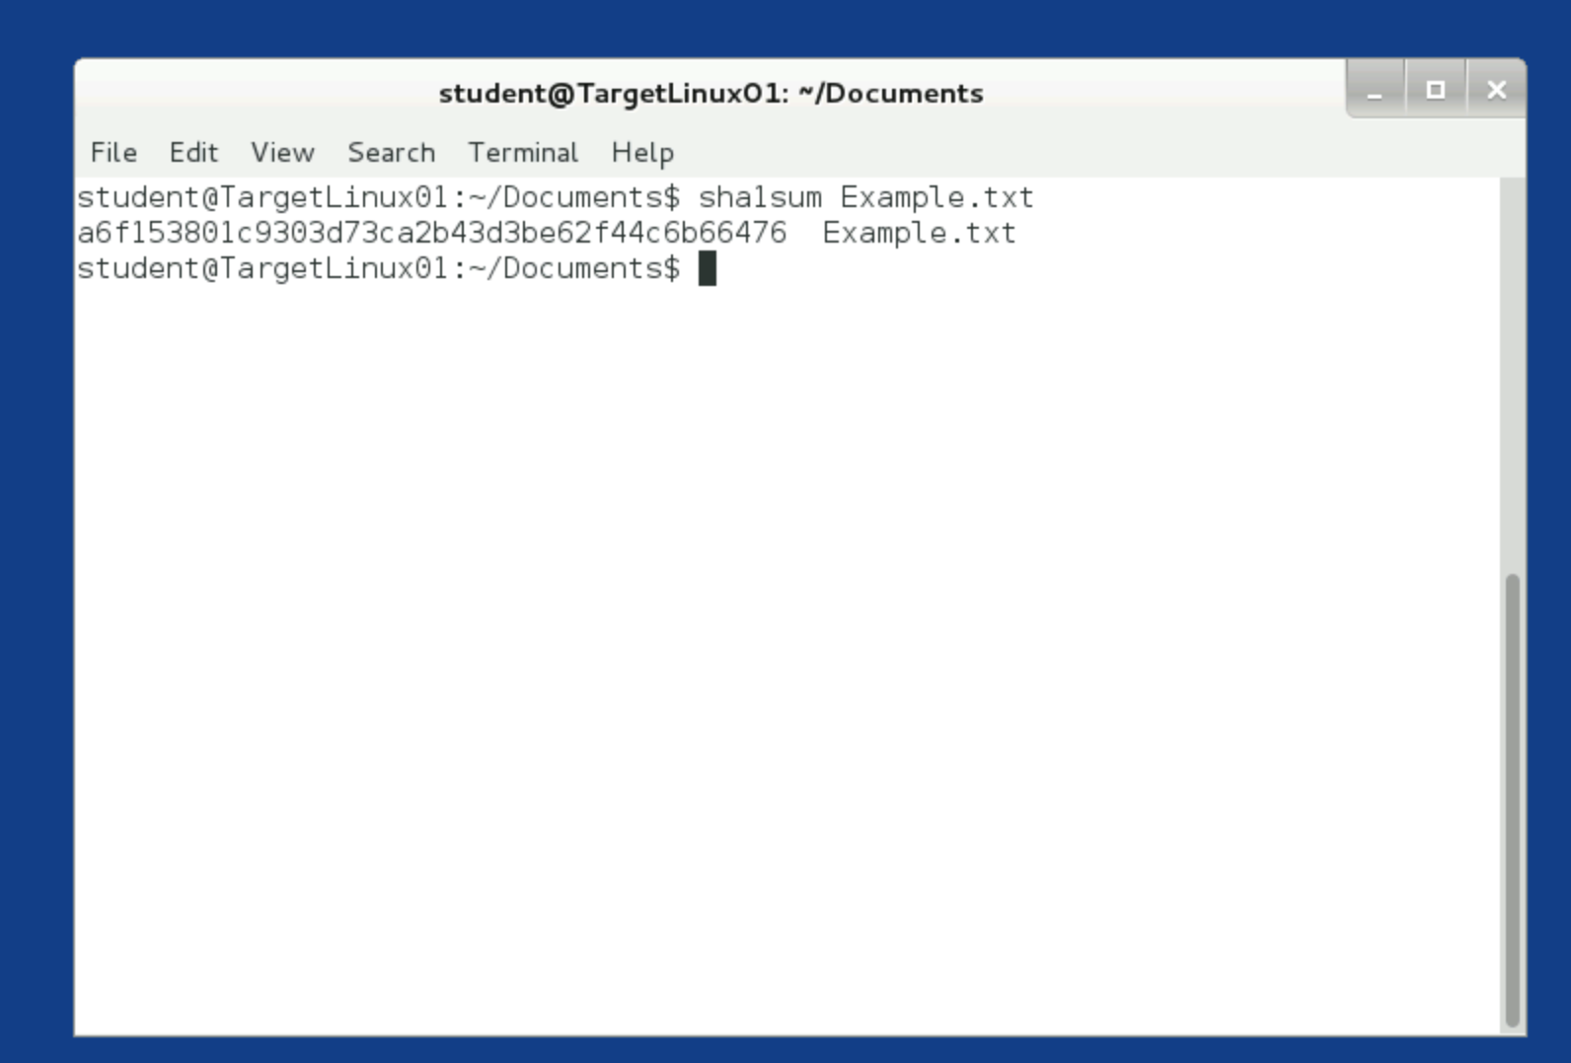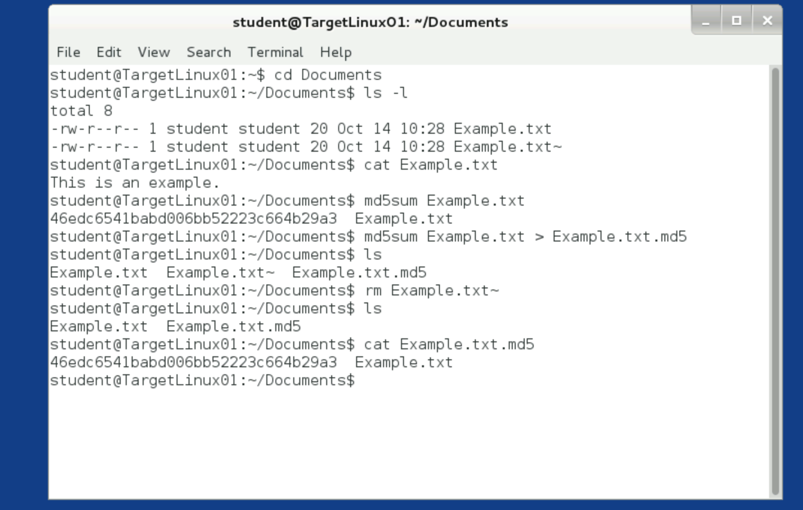

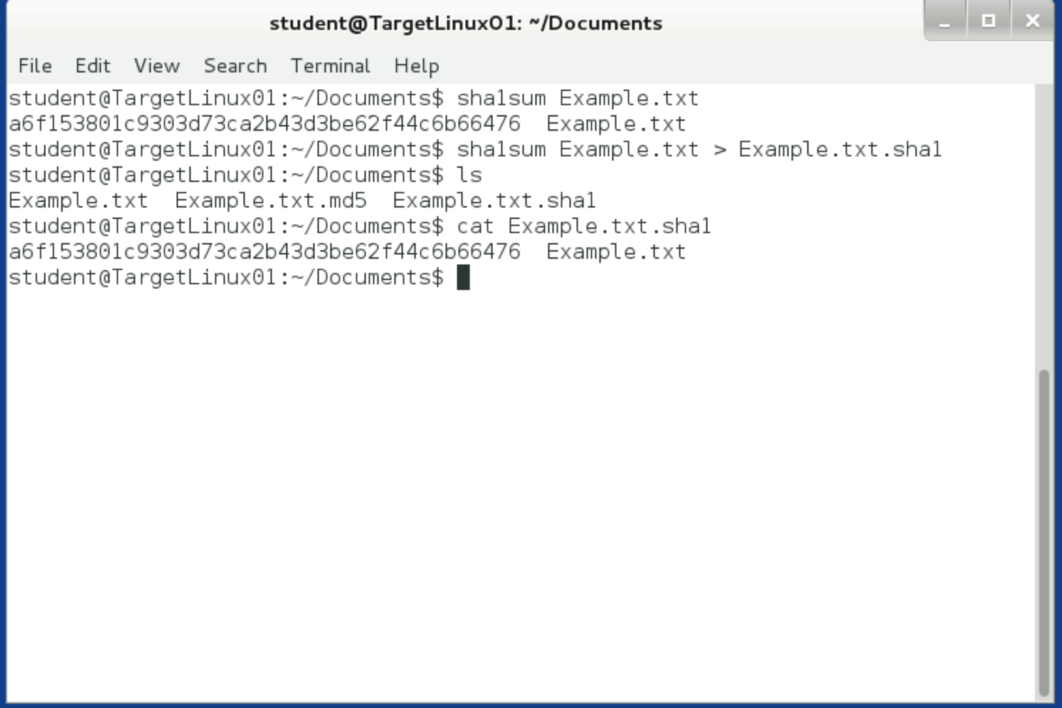

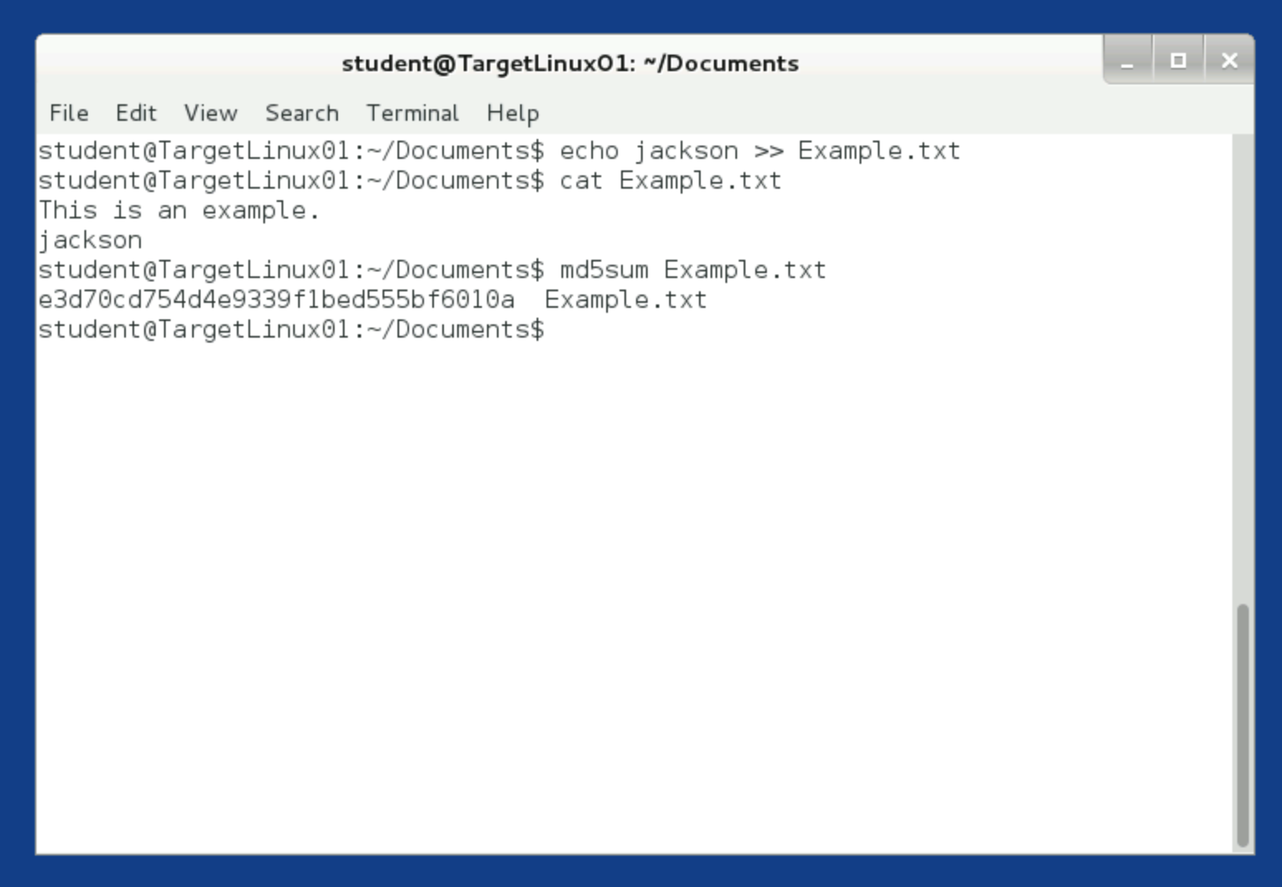

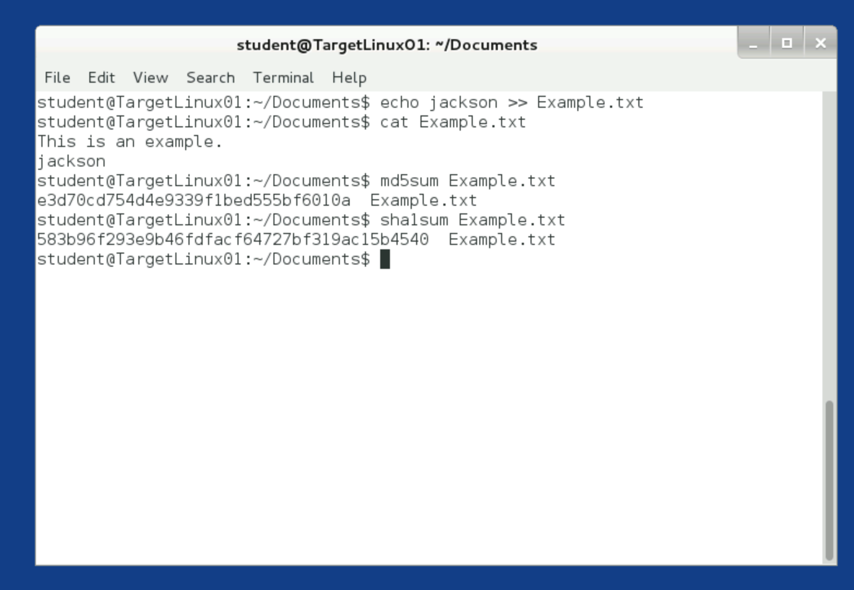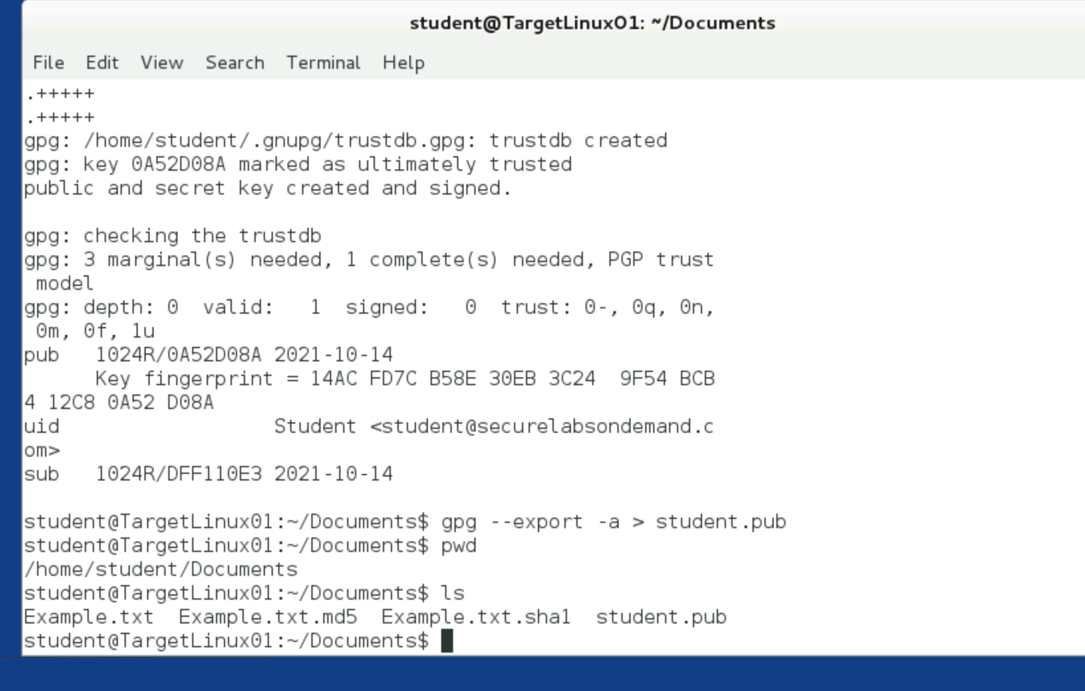

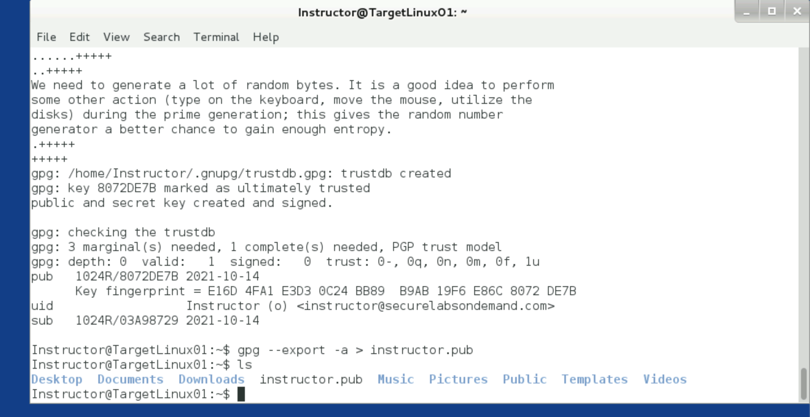

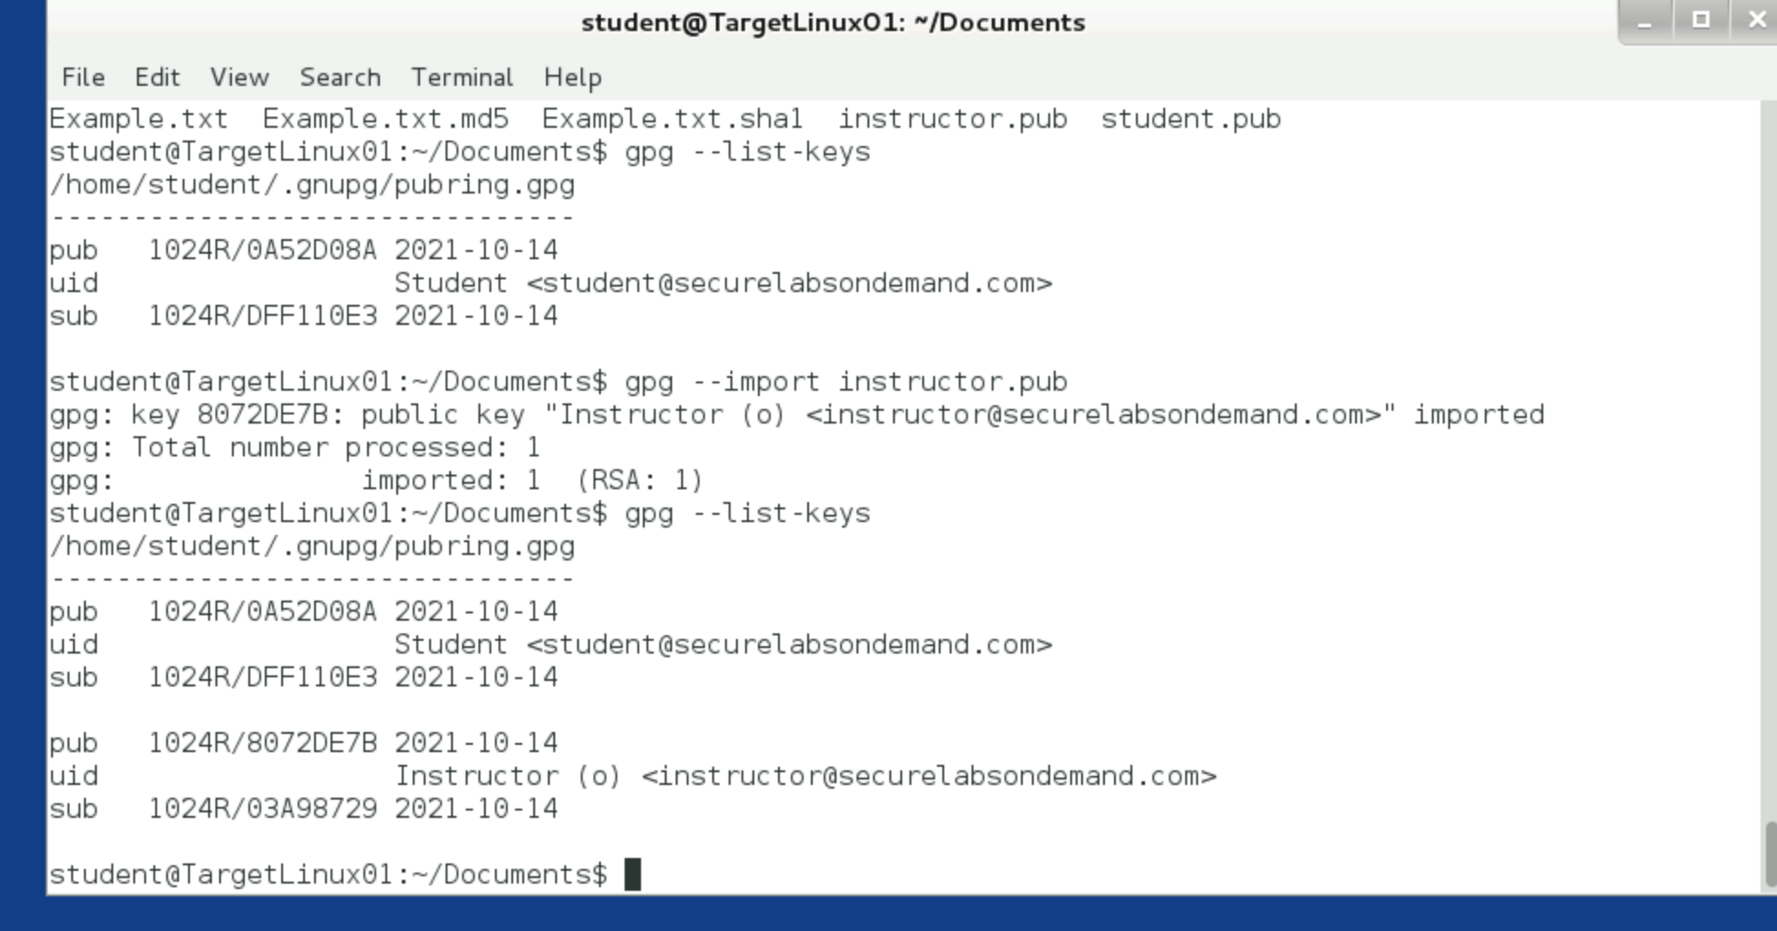

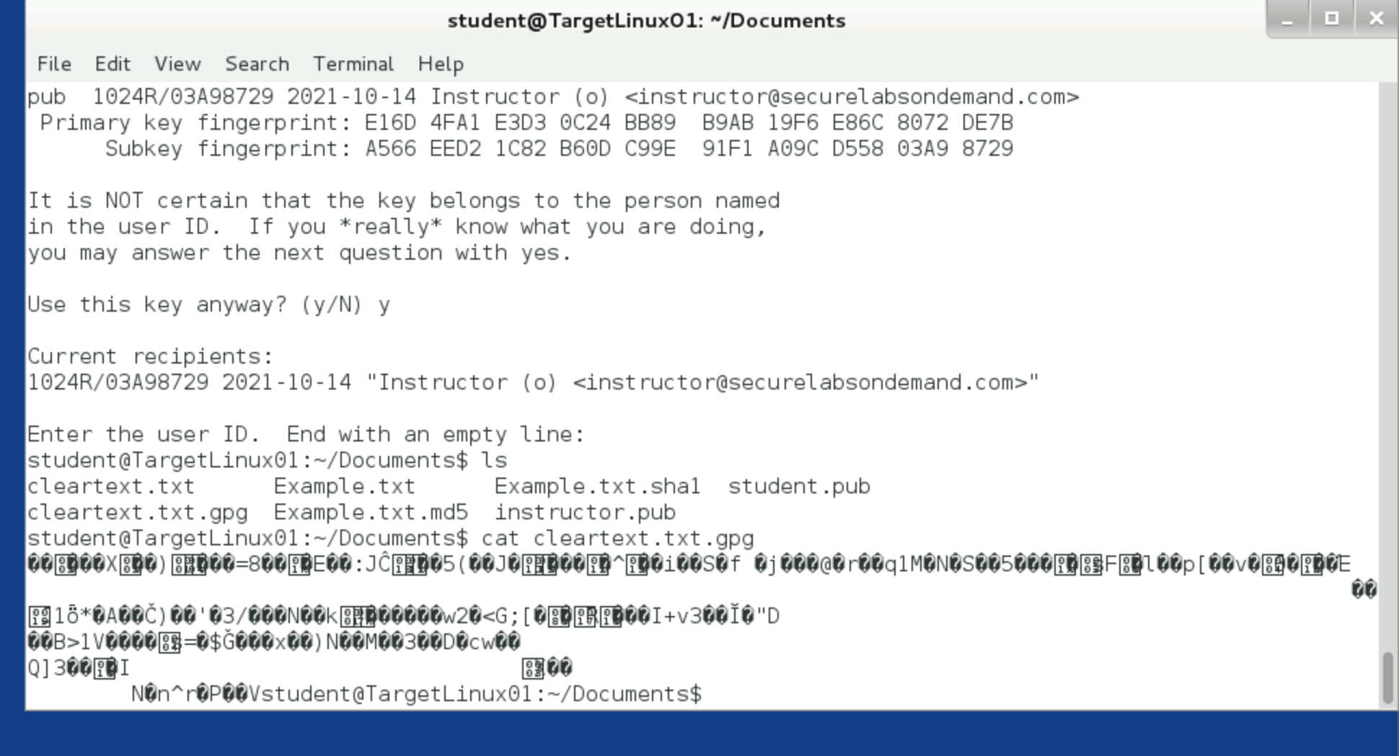

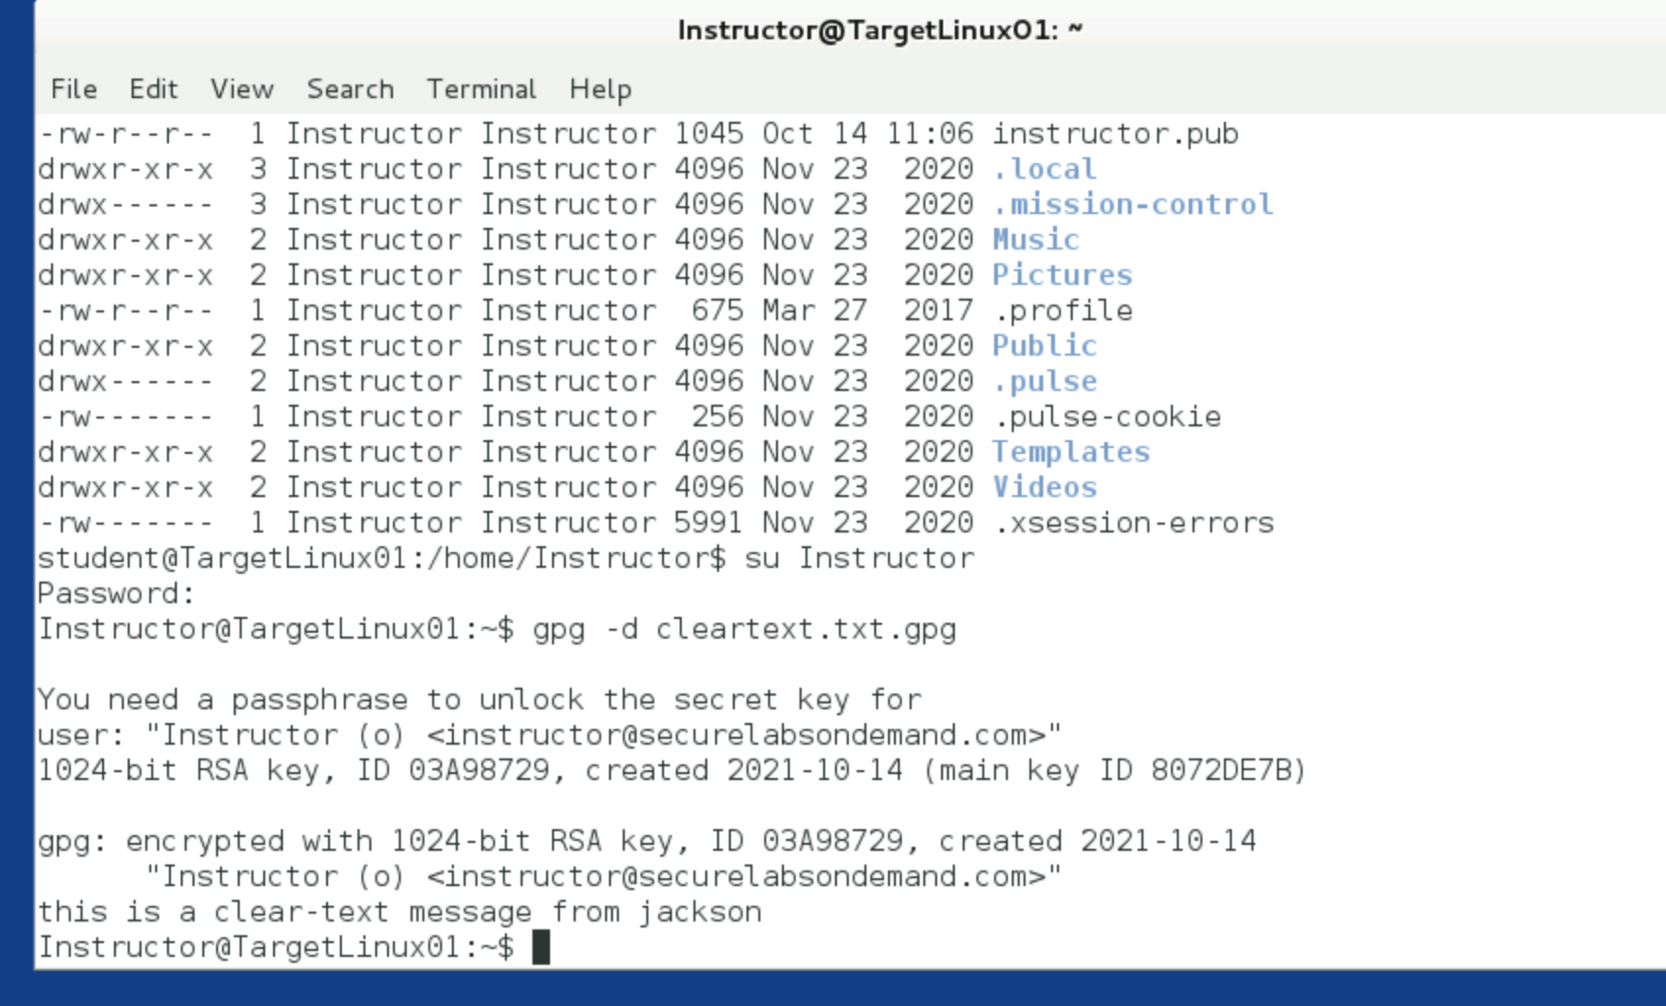

Section 2:

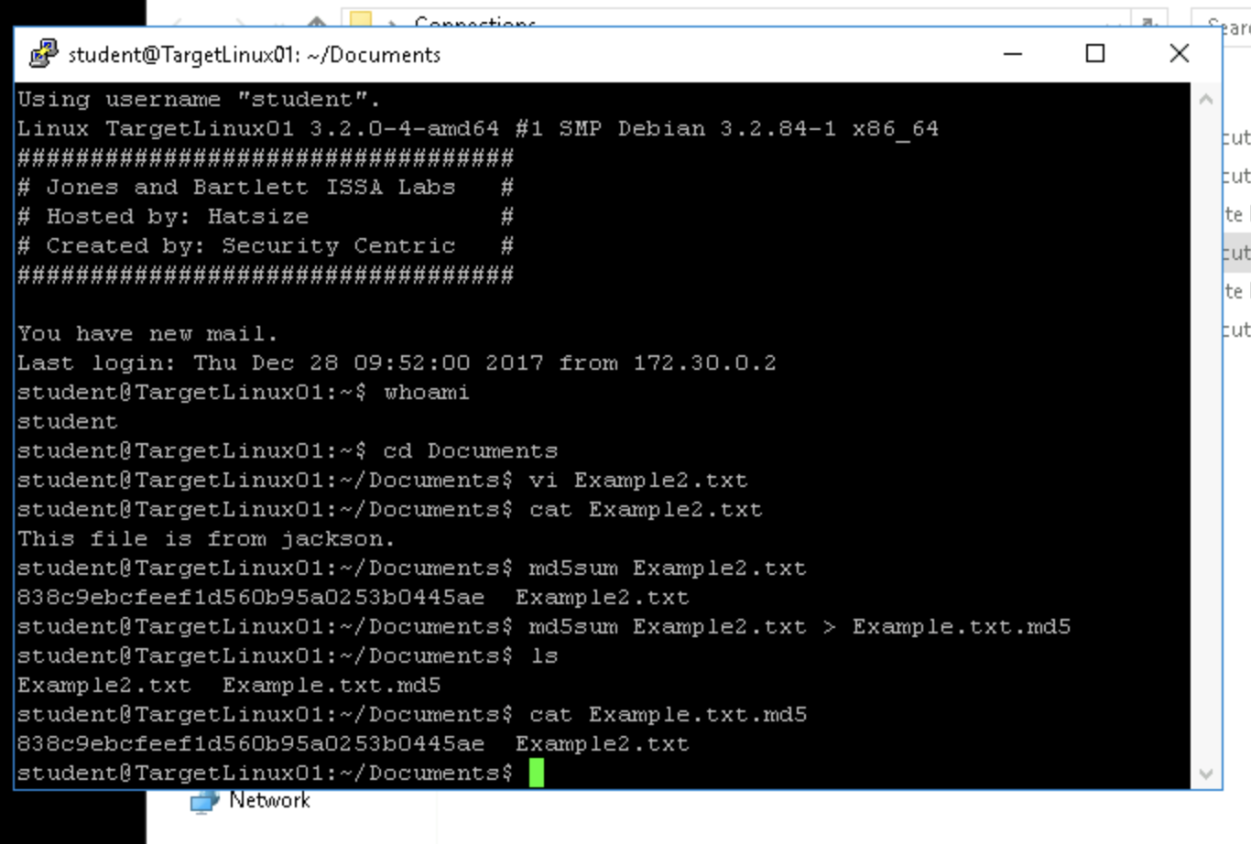

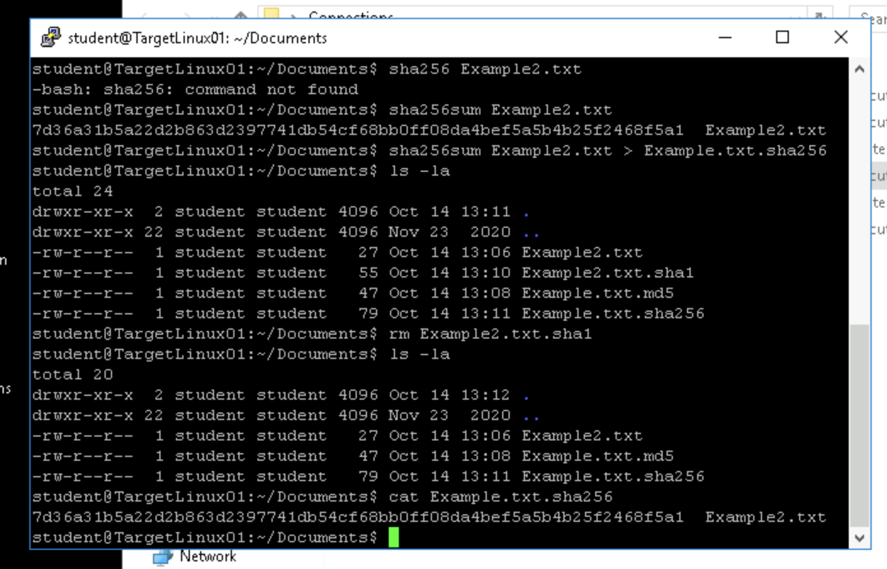

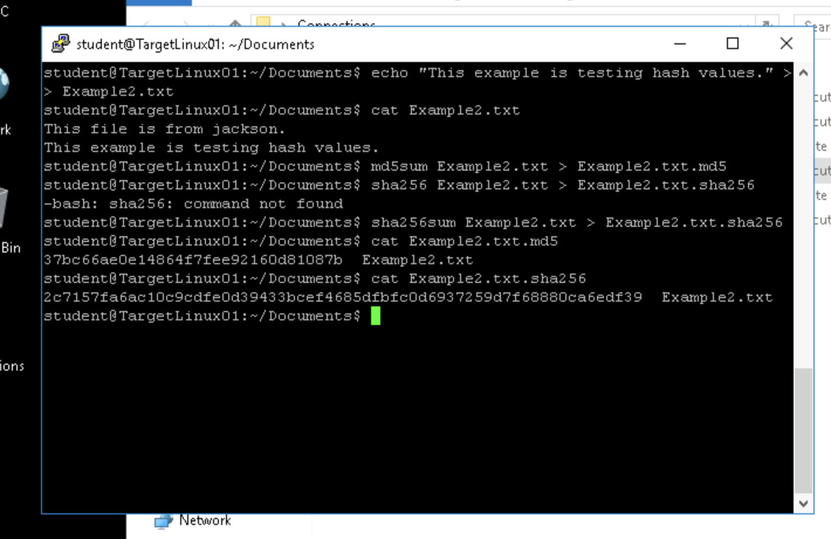

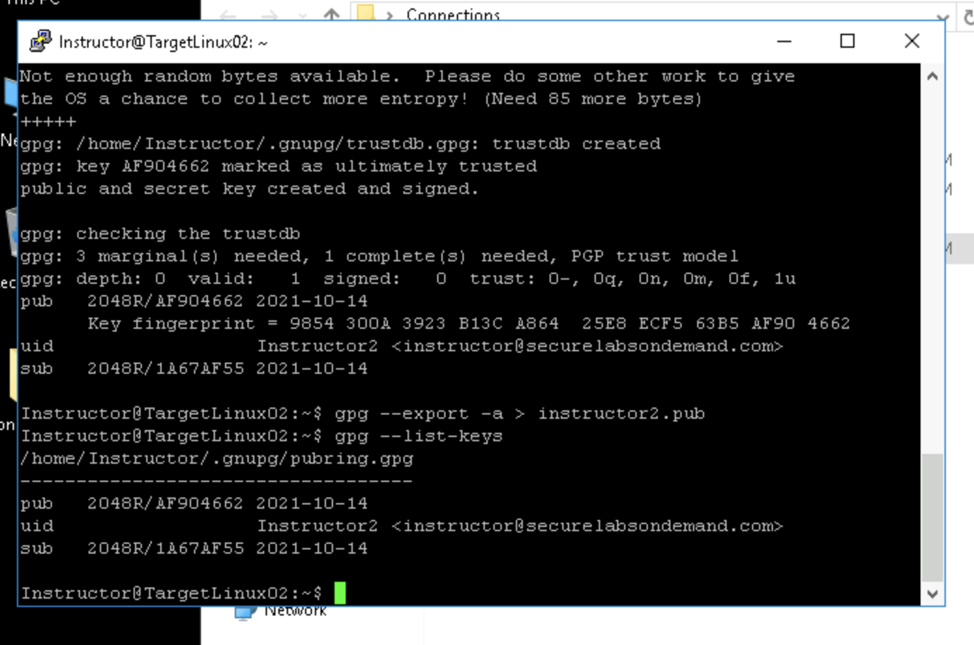

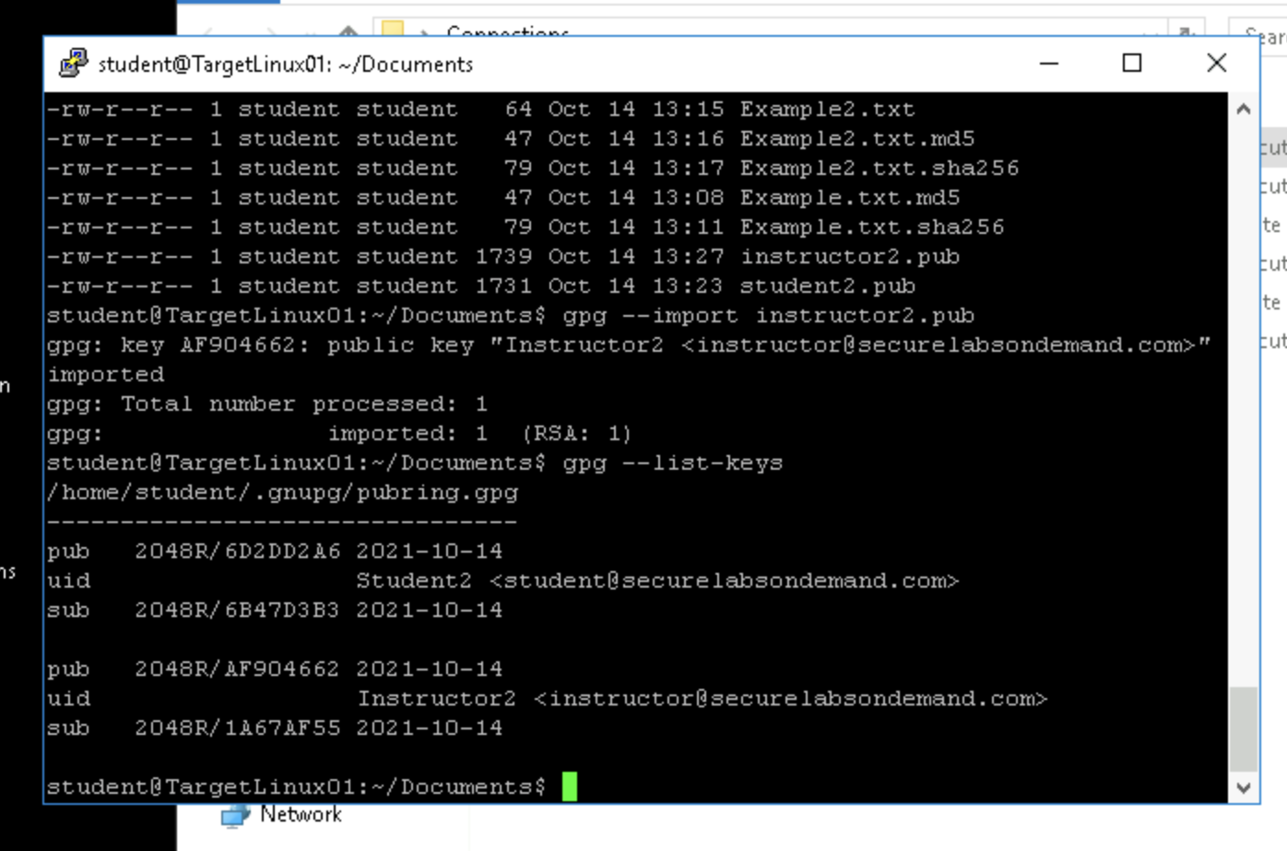

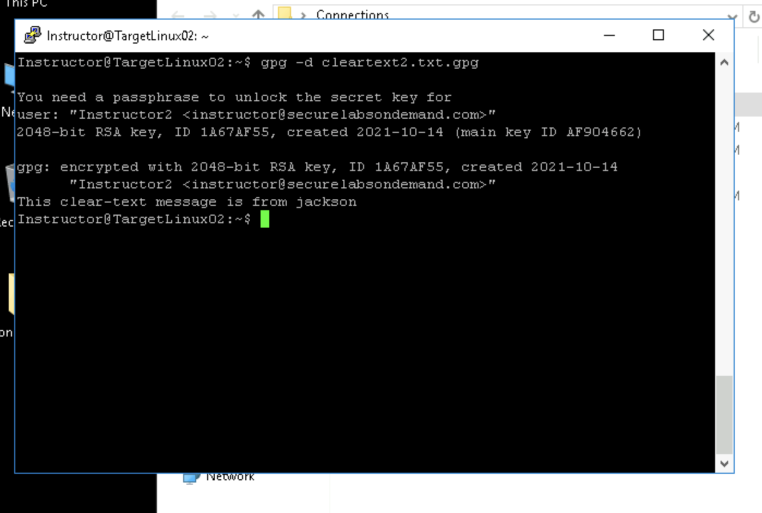

Section 3:

Part 1 - There are differences between RSA and ECDSA in key lengths. ECDSA has considerably longer key lengths when compared to RSA, which makes RSA faster, but makes ECDSA much more secure with longer keys. It also utilizes ECC, which helps at shorter key lengths as well, but is not fully supported. With the threat of Quantum-Computing, being broken using brute-force becomes a threat as well. RSA is said to be slightly harder to crack under these circumstances. Overall, RSA is more broadly used and accepted, and in general can be faster. ECDSA does have some advantages, but is slightly less used.

Part 2 – I’m going to be honest, Part 2 is asking us to re-do things we’ve already done twice in the previous parts. None of the steps differ from what we’ve already done besides file names, so I will be skipping this part.

Part 3 - 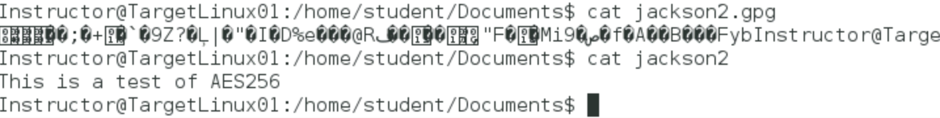

This is both the encrypted version and the decrypted versions side-by-side.

References:

Thakkar, J. (2020, August 31). *ECDSA vs RSA: Everything You Need to Know*. InfoSec Insights. https://sectigostore.com/blog/ecdsa-vs-rsa-everything-you-need-to-know/